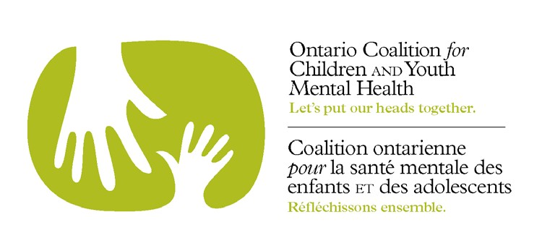
CALL FOR PRESENTERS BREAK-OUT SESSIONS
SUMMIT FOR CHILDREN AND YOUTH MENTAL HEALTH
HOSTED BY THE ONTARIO COALITION FOR CHILDREN AND YOUTH MENTAL HEALTH APRIL 12 & 13, 2018 – TORONTO –ALLSTREAM CENTRE
This is a call for presentations that will be delivered in the Summit break-out sessions scheduled for Friday April 13, 2018.

The 2018 Summit for Children and Youth Mental Health is entitled Beyond Collaboration: Towards Integrated Systems for Supporting Child and Youth Mental Health. Presentations are to focus on working across tiered systems of support for promotion, prevention and intervention. The Summit is designed to provide materials, resources, practices, protocols and programs that can be replicated and scaled up in communities across the province. We are seeking dynamic, interactive presentations that will illustrate collaborative and innovative approaches that are research based and evidence informed that are making a difference in the lives of children, youth and their families.

Special consideration will be given to presentation proposals that deepen knowledge of:
- Indigenous perspectives;
- Engagement of faith and cultural communities;
- Prevention of Self-Harm;
- Initiatives that showcase:
  - effective cross sectoral collaboration.
  - transitioning
  - transformational practice.

Priority will be given to programs/initiatives whose impact has been demonstrated through an evaluative, evidence based process. Sessions with a focus on youth

and/or families and sessions delivered in the French language are particularly welcomed.

GENERAL INFORMATION

- Speaker submissions are due on or before September 29, 2017.
- Successful candidates will be notified of acceptance by October 27, 2017
- Break-out sessions are 1 hour (includes 10 minute Q & A)
- The Summit is hosted by the Ontario Coalition for Children and Youth Mental Health, which is a non-profit, volunteer organization. As such presenters are asked to register for the Summit but will be offered the opportunity to attend a pre-Summit session on Thursday April 12, 2018 at no charge. This offer applies to a maximum of two presenters per session. Presenters are responsible for their own travel arrangements and expenses.

- The following audio-visual equipment will be provided at no cost to the presenters: laptop computer, LCD projector, large screen, one lectern with microphone, connection to house sound and WiFi. Please indicate any other AV requirements on the attached form.
- PowerPoint presentations must be submitted electronically no later than February 9, 2018 as every participant will receive a USB key with all presentations pre-loaded. Time is needed to pre-load to USB key. Further information will be provided to the successful presenters.
- Rooms will be set up with round tables unless otherwise requested by the presenter.

- Submission can be made in either official language, and if accepted, must be delivered in the language of the submission.

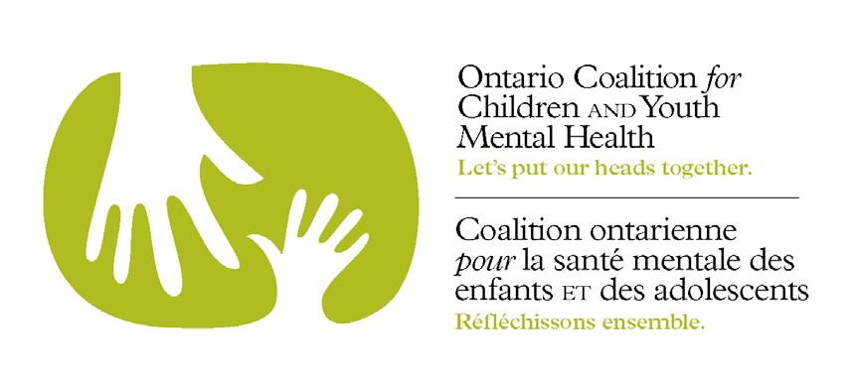
SUMMIT BREAK-OUT SESSION PROPOSAL - April 13, 2018

SPEAKER NAME AND CURRENT POSITION TITLE TO APPEAR ON PROGRAM

ORGANIZATION:

EMAIL ADDRESS __ TELEPHONE

NAMES OF PANELISTS OR OTHER CO-PRESENTERS WITH EMAIL ADDRESSES:

SESSION TITLE:

MAXIMUM 150 WORD DESCRIPTION:

____________________________________________________________________________________________

THIS PRESENTATION SUPPORTS THE FOLLOWING FOCUS OF THE 2018 SUMMIT:

Working Across Tiered Systems of Support for Promotion, Prevention, and Intervention

  - Promotion
  - Prevention
  - Intervention
◻ Other__________________________________________________________________________

__________________________________________________________________________ PLEASE INDICATE AV REQUIREMENTS
1.

2.

3.

WHERE & WHEN HAVE YOU MADE THIS PRESENTATION BEFORE?

PLEASE STATE THE DESIRED LEARNING OBJECTIVES (what the participant will take away):

1.

2.

3.

PLEASE SUBMIT PROPOSAL ELECTRONICALLY TO JUDITH NYMAN AT
jnyman@opsba.org

THE DEADLINE FOR SUBMITTING PROPOSALS IS FRIDAY, OCTOBER 6, 2017

