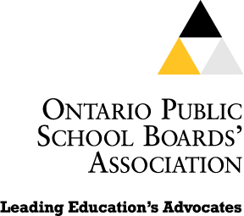 | Ontario Public School Boards’ Association  439 University Avenue, 18th Floor  Toronto, ON M5G 1Y8  Tel: (416) 340-2540  Fax: (416) 340-7571  webmaster@opsba.org  www.opsba.org | Colleen Schenk  President  Gail Anderson  Executive Director

March 19, 2010

The Honourable Chuck Strahl
Minister of Indian and Northern Affairs Canada
House of Commons
Ottawa, Ontario K1A 0A6

Dear Minister Strahl,

The Ontario Public School Boards' Association (OPSBA) represents public district school boards and public school authorities across Ontario, which together serve more than 1.2 million elementary and secondary students. The Association advocates on behalf of the best interests and needs of the public school system in Ontario and believes that the role of public education is to provide universally accessible education opportunities for all students.

Many First Nation students attend our schools under the terms of tuition agreements and many more who are resident in urban centres also receive their education in the public system. We welcome every opportunity to collaborate with First Nation communities and educators to work for the success of Ontario’s students. As the community of Attawapiskat campaigned for their much-needed school we joined our voice with theirs.

We are pleased that a decision was made by your office to commit to building a school for the children of Attawapiskat. We look forward to the day when the new school opens and puts an end to the learning conditions Attawapiskat students have endured for several years. We urge you as well to consider the similar school accommodation needs that exist in other First Nation communities and look forward to the day when a healthy, welcoming school is the norm for all students.

This is a welcome and encouraging step forward.

Thank you.
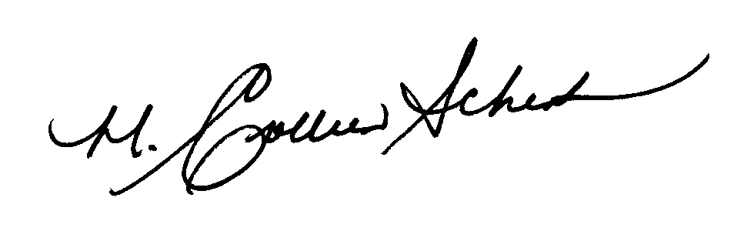

Colleen Schenk
President

