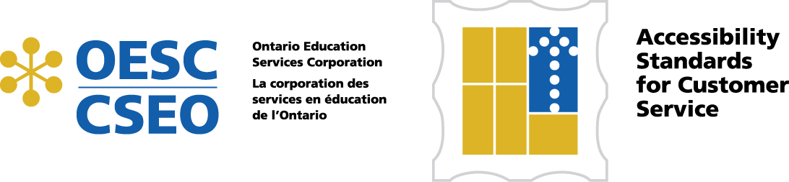

Accessible Ontario: Customer Service Guide for School Boards
CONTENTS
Accessible Ontario – Introduction
Acknowledgements
Accessible Ontario: Customer Service Documents:
- Exemplar Policy for Customer Service – Explanatory Notes and Definitions
- Exemplar Policy for Customer Service
- Exemplar Procedures – Explanatory Note
- Exemplar Procedure re Notification of Disruption of Service
- Exemplar Procedure re Use of Assistive Devices by the General Public
- Exemplar Procedure re Use of Support Person by the General Public
- Exemplar Procedure re Use of Service Animals by the General Public
- Exemplar Procedure re Monitoring and Feedback on Accessible Customer Service
- Checklist for Compliance with Accessible Customer Service Regulation
Other Resources
- Useful web links
- Sample Equity, Diversity and Inclusion Policy (Kawartha Pine Ridge DSB)
- Sample Board adaptation of Exemplar Policy

