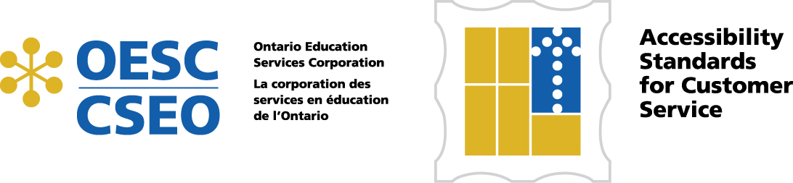

Accessibility Ontario – Customer Service: A Guide for School Boards

Exemplar Policy – Explanatory Notes
It is expected that School Boards will see the Customer Service exemplar policy as part of a larger context. The Accessibility Working Group concluded that this policy would best fit under the umbrella of “Equity”. This area of policy in school boards has, over time, become proactive and grown beyond a complaints driven process. To add clarity to the concept of proactive approaches in an umbrella equity policy, we have included, as a sample, the Equity, Diversity and Inclusion policy of the Kawartha-Pine Ridge District School Board. This is, we feel, a useful example of the approach recommended by the Working Group.
While an “Equity” policy is the umbrella we have considered, a school board may have a policy structure that calls for another approach. It is not a requirement of the Accessibility for Ontarians with Disabilities Act, 2005 to have an umbrella policy. It is however, a requirement to have a policy addressing Customer Service. There are also requirements for certain issues to be addressed in the policy. Using the exemplar we have provided and taking guidance from the checklist also included in this package will be helpful to school boards in preparing for compliance with the Customer Service Regulation.
Definitions
It should be noted that the Accessibility Working Group has used the language and terminology of the AODA (Accessibility for Ontarians with Disabilities Act, 2005) and/or the Accessibility Directorate’s (Compliance Manual: Accessibility Standards for Customer Service, Ontario Regulation 429/07) throughout this Guide. We have done so in the hope that this language, as it is progressively adopted by all private and public organizations, will become standard by 2025.
Integration
The more commonly used term in school boards is “inclusion”. This word “integration” was chosen to be consistent with the language of the regulation but aligns with our commonly accepted definition of inclusion.
Customer
School Boards have addressed the special needs of students for many years. The scope of this policy is more far reaching than students. The policy applies to all members of the public who have disabilities and may require particular considerations in order to access the services provided by a school board.

Exemplar Policy – Explanatory Notes Accessibility Ontario – Customer Service 2

While it is not usual practice for a school board to employ the term “customer” in its interaction with the public, this is the terminology used in the Accessibility for Ontarians with Disabilities Act, 2005 and is included in the title of the first standard to come into force as a Regulation under the Act, Accessibility Standards for Customer Service, Ontario Regulation 429/07. The Working Group came to the conclusion that the term “customer service” actually helps to shift conventional thinking within the educational sector from an internal focus to one that includes both internal and external service.
Service Animal
The definition is fairly broad but may be further clarified in a procedure that accompanies this policy. The reasons for use of a service animal continue to grow. There will be situations, for example, where it is not evident that a person with a disability requires a service animal and, in such cases, a note from a medical practitioner may be required.
Additionally, the most commonly used service animal is a dog. In fact, many school boards already have experience in dealing with service dogs in schools. A separate procedure for the student or staff use of a service dog would be necessary. The procedure contained in this guide addresses the use of a service animal by a member of the general public. “Service Animal” is the term used in the regulation and so it is the term we have chosen for the procedure.
Support Person
School Boards most commonly use this term to mean a person supporting a student in a classroom. When developing a procedure school boards will need to ensure a clear differentiation between a support person employed by the school board and a support person accompanying a member of the general public who has a disability requiring the assistance of another individual.
The procedure we have outlined in this guide attempts to clarify the difference. However, the Working Committee has noted that there are school boards that have addressed this concern with a further clarification.
Working Environments
References to staff in this exemplar are meant to be inclusionary. However, an Accessibility in Employment Regulation under the AODA is anticipated. This will provide further clarification to school boards about their responsibility to their employees.

