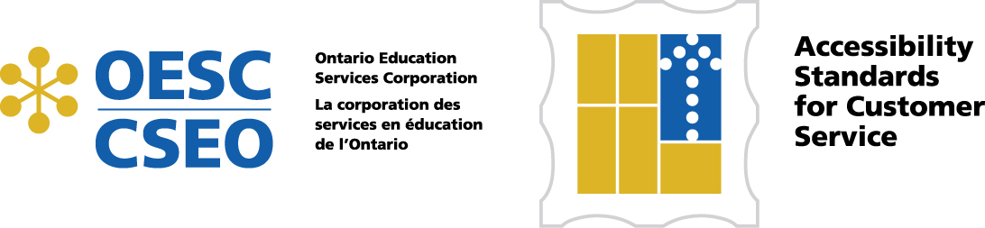

Procedures
Each one of the procedures contained in this section relates back to a section of the exemplar policy. If a school board has made significant modifications to the exemplar policy, a review should be done to ensure the procedures remain aligned.
The procedures in this section are all required under the legislation. If a school board combines or adjusts the procedures care must be taken to ensure the requirements of the legislation are still met.
The language used refers to language from the regulation in most cases. Please be reminded that these procedures refer to “Customer Service” as it relates to members of the public, including parents. School boards will already have other policies and procedures relating to staff and students with regard to accessibility, inclusion and equity. The Accessibility Working Group recommends that for legal reasons policies and procedures for staff and students, for example those related to the use of service animals or support persons, should be separate from those for the public.

