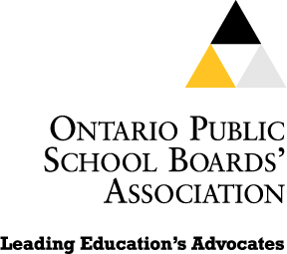 | Ontario Public School Boards’ Association  439 University Avenue, 18th Floor  Toronto, ON M5G 1Y8  Tel: (416) 340-2540  Fax: (416) 340-7571  webmaster@opsba.org  www.opsba.org | Catherine Fife  President  Gail Anderson  Executive Director
June 7, 2010

Chief Theresa Hall
Attawapiskat First Nation
P.O. Box 268,
Attawapiskat, ON P0L 1A0

Dear Chief Hall

It was with deep sadness that we learned of the tragic death of Shannen Koostachin. It is a sorrowful loss for your community and a loss for Canada when such a bright light is extinguished so prematurely.

I had the personal privilege of meeting Shannen when she came to speak so eloquently at the student-organized Human Rights Forum in Toronto in November, 2008. That was an event that grew out of your community to inspire students across Ontario and across Canada about the rights of the children of Attawapiskat and, the rights of all children, to be educated in a well-equipped and healthy school.

Shannen was a leader with strength and wisdom far beyond her years. What she gave to her fellow students and to all of us was hope for a better, more equitable world. She taught us a great deal about standing up against injustice. She has left all of us a lasting legacy and we are confident that her spirit will flow as a force for good in our world.

Please let your community and, in particular, Shannen’s family know that our thoughts are with them.

Sincerely,

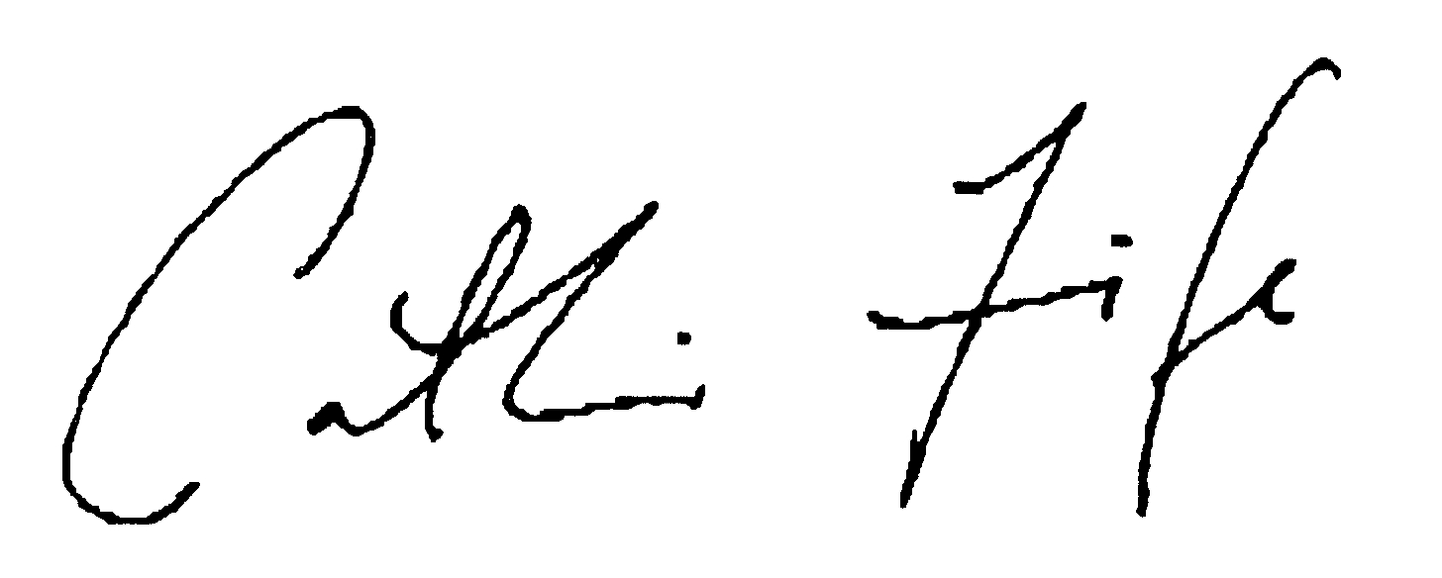
Catherine Fife
President

Copy: The Honourable Chuck Strahl, Minister of Indian and Northern Affairs
Marc Lemay, MP, Bloc Québécois, Indian and Northern Affairs Critic
Jean Crowder, MP, NDP Caucus Chair, First Nation, Métis and Inuit Affairs
Todd, Russell, MP, Liberal Critic, Aboriginal Affairs
Trustee Bruce Stonefish, First Nations Director, OPSBA

